**Experiment 37**

**Lab Book:**

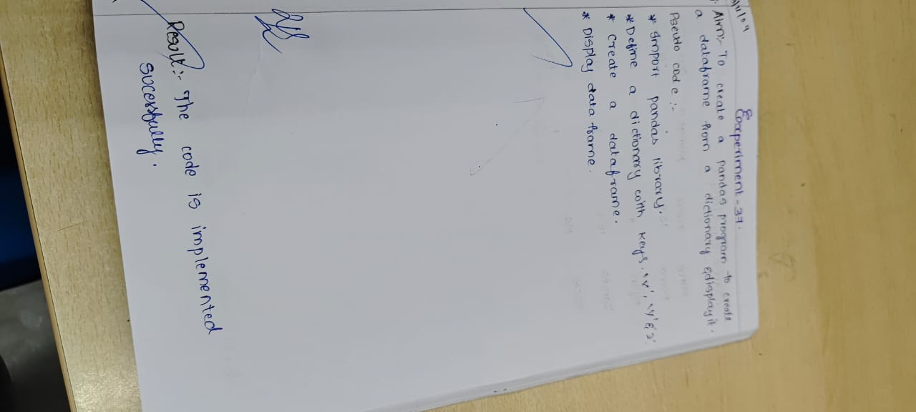

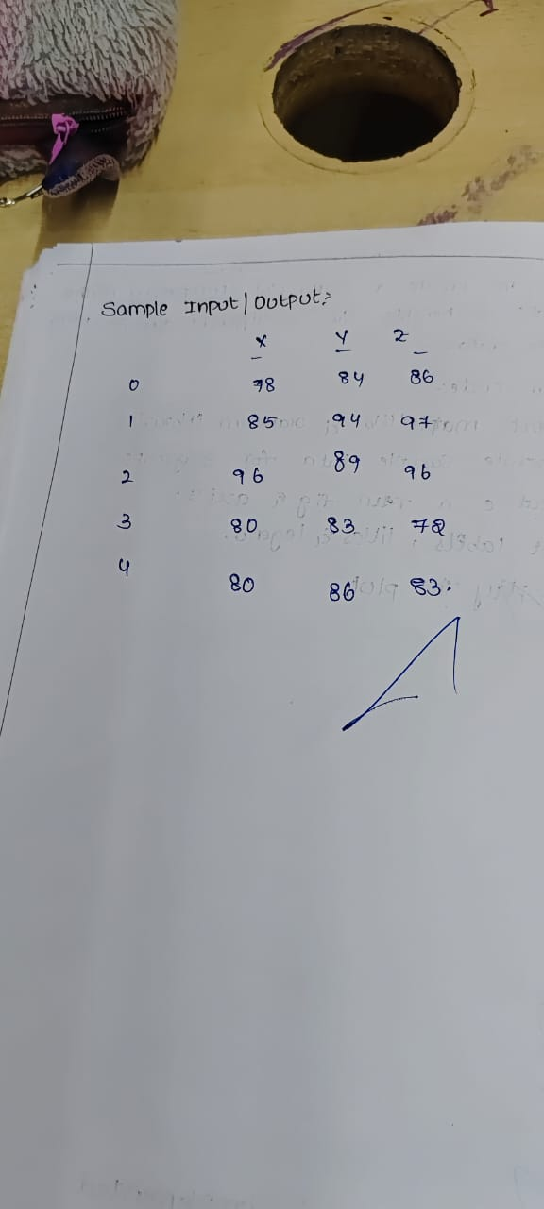

**Code**

import pandas as pd

data = {'X': [78, 85, 96, 80, 86],

'Y': [84, 94, 89, 83, 86],

'Z': [86, 97, 96, 72, 83]}

df = pd.DataFrame(data)

print(df)

**Sample Output**

